**Titanic Train Dataset**

Here, I have used Decision Tree Classifier and then Random Forest Classifier for knowing its imprtances.

Below is the diagram of Decision Tree I got from the titanic Dataset.

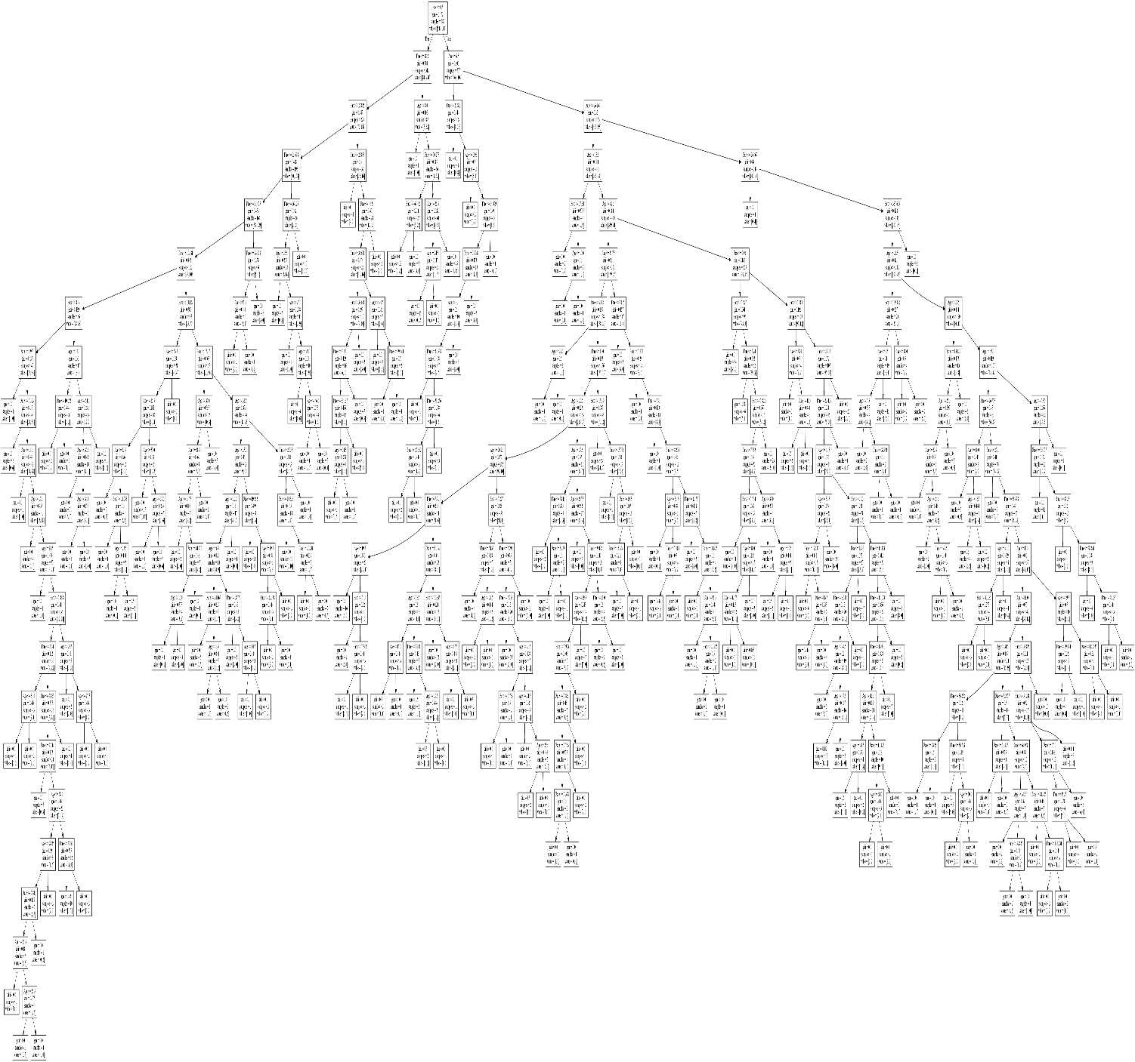

Below is the pseudo tree rule for the image

|--- Sex <= 0.50

| |--- Fare <= 48.20

| | |--- Fare <= 27.82

| | | |--- Fare <= 25.70

| | | | |--- Fare <= 24.07

| | | | | |--- Fare <= 10.48

| | | | | | |--- Fare <= 8.04

| | | | | | | |--- Fare <= 6.99

| | | | | | | | |--- class: 0

| | | | | | | |--- Fare > 6.99

| | | | | | | | |--- Fare <= 7.52

| | | | | | | | | |--- class: 1

| | | | | | | | |--- Fare > 7.52

| | | | | | | | | |--- Age <= 14.50

| | | | | | | | | | |--- class: 0

| | | | | | | | | |--- Age > 14.50

| | | | | | | | | | |--- Age <= 17.50

| | | | | | | | | | | |--- class: 1

| | | | | | | | | | |--- Age > 17.50

| | | | | | | | | | | |--- truncated branch of depth 11

| | | | | | |--- Fare > 8.04

| | | | | | | |--- Age <= 19.00

| | | | | | | | |--- Fare <= 10.15

| | | | | | | | | |--- class: 1

| | | | | | | | |--- Fare > 10.15

| | | | | | | | | |--- class: 0

| | | | | | | |--- Age > 19.00

| | | | | | | | |--- Age <= 54.00

| | | | | | | | | |--- Age <= 30.50

| | | | | | | | | | |--- class: 0

| | | | | | | | | |--- Age > 30.50

| | | | | | | | | | |--- Age <= 34.00

| | | | | | | | | | | |--- class: 1

| | | | | | | | | | |--- Age > 34.00

| | | | | | | | | | | |--- class: 0

| | | | | | | | |--- Age > 54.00

| | | | | | | | | |--- class: 1

| | | | | |--- Fare > 10.48

| | | | | | |--- Fare <= 14.13

| | | | | | | |--- Age <= 53.50

| | | | | | | | |--- Age <= 25.50

| | | | | | | | | |--- Age <= 21.50

| | | | | | | | | | |--- class: 1

| | | | | | | | | |--- Age > 21.50

| | | | | | | | | | |--- Fare <= 11.76

| | | | | | | | | | | |--- class: 0

| | | | | | | | | | |--- Fare > 11.76

| | | | | | | | | | | |--- truncated branch of depth 2

| | | | | | | | |--- Age > 25.50

| | | | | | | | | |--- Age <= 37.00

| | | | | | | | | | |--- class: 1

| | | | | | | | | |--- Age > 37.00

| | | | | | | | | | |--- Age <= 39.00

| | | | | | | | | | | |--- class: 0

| | | | | | | | | | |--- Age > 39.00

| | | | | | | | | | | |--- class: 1

| | | | | | | |--- Age > 53.50

| | | | | | | | |--- class: 0

| | | | | | |--- Fare > 14.13

| | | | | | | |--- Fare <= 15.37

| | | | | | | | |--- Age <= 37.00

| | | | | | | | | |--- Age <= 28.50

| | | | | | | | | | |--- Age <= 14.75

| | | | | | | | | | | |--- class: 0

| | | | | | | | | | |--- Age > 14.75

| | | | | | | | | | | |--- truncated branch of depth 3

| | | | | | | | | |--- Age > 28.50

| | | | | | | | | | |--- class: 1

| | | | | | | | |--- Age > 37.00

| | | | | | | | | |--- class: 0

| | | | | | | |--- Fare > 15.37

| | | | | | | | |--- Age <= 32.50

| | | | | | | | | |--- Age <= 25.00

| | | | | | | | | | |--- Age <= 21.00

| | | | | | | | | | | |--- truncated branch of depth 4

| | | | | | | | | | |--- Age > 21.00

| | | | | | | | | | | |--- class: 1

| | | | | | | | | |--- Age > 25.00

| | | | | | | | | | |--- Fare <= 19.26

| | | | | | | | | | | |--- class: 0

| | | | | | | | | | |--- Fare > 19.26

| | | | | | | | | | | |--- truncated branch of depth 3

| | | | | | | | |--- Age > 32.50

| | | | | | | | | |--- Fare <= 23.35

| | | | | | | | | | |--- Fare <= 19.86

| | | | | | | | | | | |--- class: 1

| | | | | | | | | | |--- Fare > 19.86

| | | | | | | | | | | |--- truncated branch of depth 2

| | | | | | | | | |--- Fare > 23.35

| | | | | | | | | | |--- class: 0

| | | | |--- Fare > 24.07

| | | | | |--- Fare <= 24.81

| | | | | | |--- Age <= 37.50

| | | | | | | |--- class: 0

| | | | | | |--- Age > 37.50

| | | | | | | |--- class: 1

| | | | | |--- Fare > 24.81

| | | | | | |--- class: 0

| | | |--- Fare > 25.70

| | | | |--- Fare <= 26.12

| | | | | |--- Age <= 25.50

| | | | | | |--- class: 1

| | | | | |--- Age > 25.50

| | | | | | |--- Age <= 27.00

| | | | | | | |--- class: 0

| | | | | | |--- Age > 27.00

| | | | | | | |--- Age <= 43.00

| | | | | | | | |--- class: 1

| | | | | | | |--- Age > 43.00

| | | | | | | | |--- Age <= 46.00

| | | | | | | | | |--- class: 0

| | | | | | | | |--- Age > 46.00

| | | | | | | | | |--- class: 1

| | | | |--- Fare > 26.12

| | | | | |--- class: 1

| | |--- Fare > 27.82

| | | |--- Fare <= 28.86

| | | | |--- class: 0

| | | |--- Fare > 28.86

| | | | |--- Fare <= 44.24

| | | | | |--- Fare <= 36.69

| | | | | | |--- Fare <= 33.69

| | | | | | | |--- Fare <= 31.33

| | | | | | | | |--- Fare <= 31.14

| | | | | | | | | |--- Age <= 34.50

| | | | | | | | | | |--- class: 1

| | | | | | | | | |--- Age > 34.50

| | | | | | | | | | |--- class: 0

| | | | | | | | |--- Fare > 31.14

| | | | | | | | | |--- class: 0

| | | | | | | |--- Fare > 31.33

| | | | | | | | |--- class: 1

| | | | | | |--- Fare > 33.69

| | | | | | | |--- class: 0

| | | | | |--- Fare > 36.69

| | | | | | |--- Age <= 40.50

| | | | | | | |--- class: 1

| | | | | | |--- Age > 40.50

| | | | | | | |--- Fare <= 39.64

| | | | | | | | |--- class: 1

| | | | | | | |--- Fare > 39.64

| | | | | | | | |--- class: 0

| | | | |--- Fare > 44.24

| | | | | |--- class: 0

| |--- Fare > 48.20

| | |--- Age <= 8.00

| | | |--- class: 0

| | |--- Age > 8.00

| | | |--- Fare <= 70.28

| | | | |--- Fare <= 69.43

| | | | | |--- class: 1

| | | | |--- Fare > 69.43

| | | | | |--- class: 0

| | | |--- Fare > 70.28

| | | | |--- Age <= 25.50

| | | | | |--- Age <= 24.50

| | | | | | |--- class: 1

| | | | | |--- Age > 24.50

| | | | | | |--- class: 0

| | | | |--- Age > 25.50

| | | | | |--- class: 1

|--- Sex > 0.50

| |--- Age <= 6.50

| | |--- Fare <= 20.83

| | | |--- class: 1

| | |--- Fare > 20.83

| | | |--- Age <= 0.96

| | | | |--- class: 1

| | | |--- Age > 0.96

| | | | |--- Fare <= 64.38

| | | | | |--- Fare <= 39.34

| | | | | | |--- Age <= 3.50

| | | | | | | |--- Fare <= 23.54

| | | | | | | | |--- class: 0

| | | | | | | |--- Fare > 23.54

| | | | | | | | |--- Fare <= 30.26

| | | | | | | | | |--- Fare <= 27.56

| | | | | | | | | | |--- class: 1

| | | | | | | | | |--- Fare > 27.56

| | | | | | | | | | |--- class: 0

| | | | | | | | |--- Fare > 30.26

| | | | | | | | | |--- class: 1

| | | | | | |--- Age > 3.50

| | | | | | | |--- class: 0

| | | | | |--- Fare > 39.34

| | | | | | |--- class: 0

| | | | |--- Fare > 64.38

| | | | | |--- class: 1

| |--- Age > 6.50

| | |--- Fare <= 26.27

| | | |--- Age <= 13.50

| | | | |--- Fare <= 17.34

| | | | | |--- class: 1

| | | | |--- Fare > 17.34

| | | | | |--- Age <= 10.00

| | | | | | |--- class: 1

| | | | | |--- Age > 10.00

| | | | | | |--- class: 0

| | | |--- Age > 13.50

| | | | |--- Age <= 32.50

| | | | | |--- Age <= 30.75

| | | | | | |--- Fare <= 2.01

| | | | | | | |--- Age <= 22.00

| | | | | | | | |--- class: 0

| | | | | | | |--- Age > 22.00

| | | | | | | | |--- class: 1

| | | | | | |--- Fare > 2.01

| | | | | | | |--- Fare <= 11.00

| | | | | | | | |--- Age <= 26.50

| | | | | | | | | |--- Age <= 20.25

| | | | | | | | | | |--- Fare <= 7.91

| | | | | | | | | | | |--- truncated branch of depth 4

| | | | | | | | | | |--- Fare > 7.91

| | | | | | | | | | | |--- truncated branch of depth 5

| | | | | | | | | |--- Age > 20.25

| | | | | | | | | | |--- Fare <= 7.23

| | | | | | | | | | | |--- truncated branch of depth 3

| | | | | | | | | | |--- Fare > 7.23

| | | | | | | | | | | |--- truncated branch of depth 6

| | | | | | | | |--- Age > 26.50

| | | | | | | | | |--- Age <= 27.50

| | | | | | | | | | |--- Fare <= 7.85

| | | | | | | | | | | |--- class: 1

| | | | | | | | | | |--- Fare > 7.85

| | | | | | | | | | | |--- truncated branch of depth 2

| | | | | | | | | |--- Age > 27.50

| | | | | | | | | | |--- Age <= 28.75

| | | | | | | | | | | |--- class: 0

| | | | | | | | | | |--- Age > 28.75

| | | | | | | | | | | |--- truncated branch of depth 7

| | | | | | | |--- Fare > 11.00

| | | | | | | | |--- Fare <= 15.39

| | | | | | | | | |--- class: 0

| | | | | | | | |--- Fare > 15.39

| | | | | | | | | |--- Fare <= 15.80

| | | | | | | | | | |--- class: 1

| | | | | | | | | |--- Fare > 15.80

| | | | | | | | | | |--- Fare <= 19.50

| | | | | | | | | | | |--- truncated branch of depth 2

| | | | | | | | | | |--- Fare > 19.50

| | | | | | | | | | | |--- class: 0

| | | | | |--- Age > 30.75

| | | | | | |--- Fare <= 7.81

| | | | | | | |--- class: 0

| | | | | | |--- Fare > 7.81

| | | | | | | |--- Fare <= 7.88

| | | | | | | | |--- class: 1

| | | | | | | |--- Fare > 7.88

| | | | | | | | |--- Fare <= 7.91

| | | | | | | | | |--- class: 0

| | | | | | | | |--- Fare > 7.91

| | | | | | | | | |--- Fare <= 8.21

| | | | | | | | | | |--- Age <= 31.50

| | | | | | | | | | | |--- class: 1

| | | | | | | | | | |--- Age > 31.50

| | | | | | | | | | | |--- truncated branch of depth 2

| | | | | | | | | |--- Fare > 8.21

| | | | | | | | | | |--- Fare <= 11.75

| | | | | | | | | | | |--- class: 0

| | | | | | | | | | |--- Fare > 11.75

| | | | | | | | | | | |--- truncated branch of depth 4

| | | | |--- Age > 32.50

| | | | | |--- Fare <= 7.91

| | | | | | |--- Fare <= 7.23

| | | | | | | |--- class: 0

| | | | | | |--- Fare > 7.23

| | | | | | | |--- Fare <= 7.24

| | | | | | | | |--- class: 0

| | | | | | | |--- Fare > 7.24

| | | | | | | | |--- Fare <= 7.80

| | | | | | | | | |--- Fare <= 7.76

| | | | | | | | | | |--- Fare <= 7.74

| | | | | | | | | | | |--- class: 0

| | | | | | | | | | |--- Fare > 7.74

| | | | | | | | | | | |--- truncated branch of depth 3

| | | | | | | | | |--- Fare > 7.76

| | | | | | | | | | |--- Age <= 39.00

| | | | | | | | | | | |--- class: 0

| | | | | | | | | | |--- Age > 39.00

| | | | | | | | | | | |--- truncated branch of depth 2

| | | | | | | | |--- Fare > 7.80

| | | | | | | | | |--- class: 0

| | | | | |--- Fare > 7.91

| | | | | | |--- Fare <= 7.99

| | | | | | | |--- Age <= 38.00

| | | | | | | | |--- class: 0

| | | | | | | |--- Age > 38.00

| | | | | | | | |--- Age <= 41.50

| | | | | | | | | |--- class: 0

| | | | | | | | |--- Age > 41.50

| | | | | | | | | |--- class: 1

| | | | | | |--- Fare > 7.99

| | | | | | | |--- Fare <= 23.35

| | | | | | | | |--- Fare <= 22.46

| | | | | | | | | |--- Age <= 41.50

| | | | | | | | | | |--- Age <= 34.50

| | | | | | | | | | | |--- truncated branch of depth 3

| | | | | | | | | | |--- Age > 34.50

| | | | | | | | | | | |--- class: 0

| | | | | | | | | |--- Age > 41.50

| | | | | | | | | | |--- Fare <= 10.00

| | | | | | | | | | | |--- truncated branch of depth 5

| | | | | | | | | | |--- Fare > 10.00

| | | | | | | | | | | |--- truncated branch of depth 7

| | | | | | | | |--- Fare > 22.46

| | | | | | | | | |--- class: 1

| | | | | | | |--- Fare > 23.35

| | | | | | | | |--- class: 0

| | |--- Fare > 26.27

| | | |--- Fare <= 26.47

| | | | |--- class: 1

| | | |--- Fare > 26.47

| | | | |--- Fare <= 387.66

| | | | | |--- Age <= 22.50

| | | | | | |--- Fare <= 109.89

| | | | | | | |--- Age <= 8.50

| | | | | | | | |--- Age <= 7.50

| | | | | | | | | |--- class: 0

| | | | | | | | |--- Age > 7.50

| | | | | | | | | |--- Fare <= 32.94

| | | | | | | | | | |--- class: 0

| | | | | | | | | |--- Fare > 32.94

| | | | | | | | | | |--- class: 1

| | | | | | | |--- Age > 8.50

| | | | | | | | |--- class: 0

| | | | | | |--- Fare > 109.89

| | | | | | | |--- Age <= 18.00

| | | | | | | | |--- class: 1

| | | | | | | |--- Age > 18.00

| | | | | | | | |--- class: 0

| | | | | |--- Age > 22.50

| | | | | | |--- Age <= 27.50

| | | | | | | |--- Fare <= 151.29

| | | | | | | | |--- Age <= 25.50

| | | | | | | | | |--- Age <= 23.50

| | | | | | | | | | |--- class: 1

| | | | | | | | | |--- Age > 23.50

| | | | | | | | | | |--- Age <= 24.50

| | | | | | | | | | | |--- class: 0

| | | | | | | | | | |--- Age > 24.50

| | | | | | | | | | | |--- truncated branch of depth 2

| | | | | | | | |--- Age > 25.50

| | | | | | | | | |--- class: 1

| | | | | | | |--- Fare > 151.29

| | | | | | | | |--- class: 0

| | | | | | |--- Age > 27.50

| | | | | | | |--- Age <= 53.00

| | | | | | | | |--- Fare <= 26.77

| | | | | | | | | |--- Age <= 40.00

| | | | | | | | | | |--- class: 1

| | | | | | | | | |--- Age > 40.00

| | | | | | | | | | |--- Age <= 46.50

| | | | | | | | | | | |--- class: 0

| | | | | | | | | | |--- Age > 46.50

| | | | | | | | | | | |--- class: 1

| | | | | | | | |--- Fare > 26.77

| | | | | | | | | |--- Fare <= 29.10

| | | | | | | | | | |--- class: 0

| | | | | | | | | |--- Fare > 29.10

| | | | | | | | | | |--- Fare <= 30.60

| | | | | | | | | | | |--- truncated branch of depth 3

| | | | | | | | | | |--- Fare > 30.60

| | | | | | | | | | | |--- truncated branch of depth 8

| | | | | | | |--- Age > 53.00

| | | | | | | | |--- Age <= 75.50

| | | | | | | | | |--- Fare <= 35.08

| | | | | | | | | | |--- class: 0

| | | | | | | | | |--- Fare > 35.08

| | | | | | | | | | |--- Fare <= 37.25

| | | | | | | | | | | |--- class: 1

| | | | | | | | | | |--- Fare > 37.25

| | | | | | | | | | | |--- truncated branch of depth 3

| | | | | | | | |--- Age > 75.50

| | | | | | | | | |--- class: 1

| | | | |--- Fare > 387.66

| | | | | |--- class: 1